Lab Execisies

1. Write a R program to take input from the user (name and age) and display the values. Also print the version of R installation.  
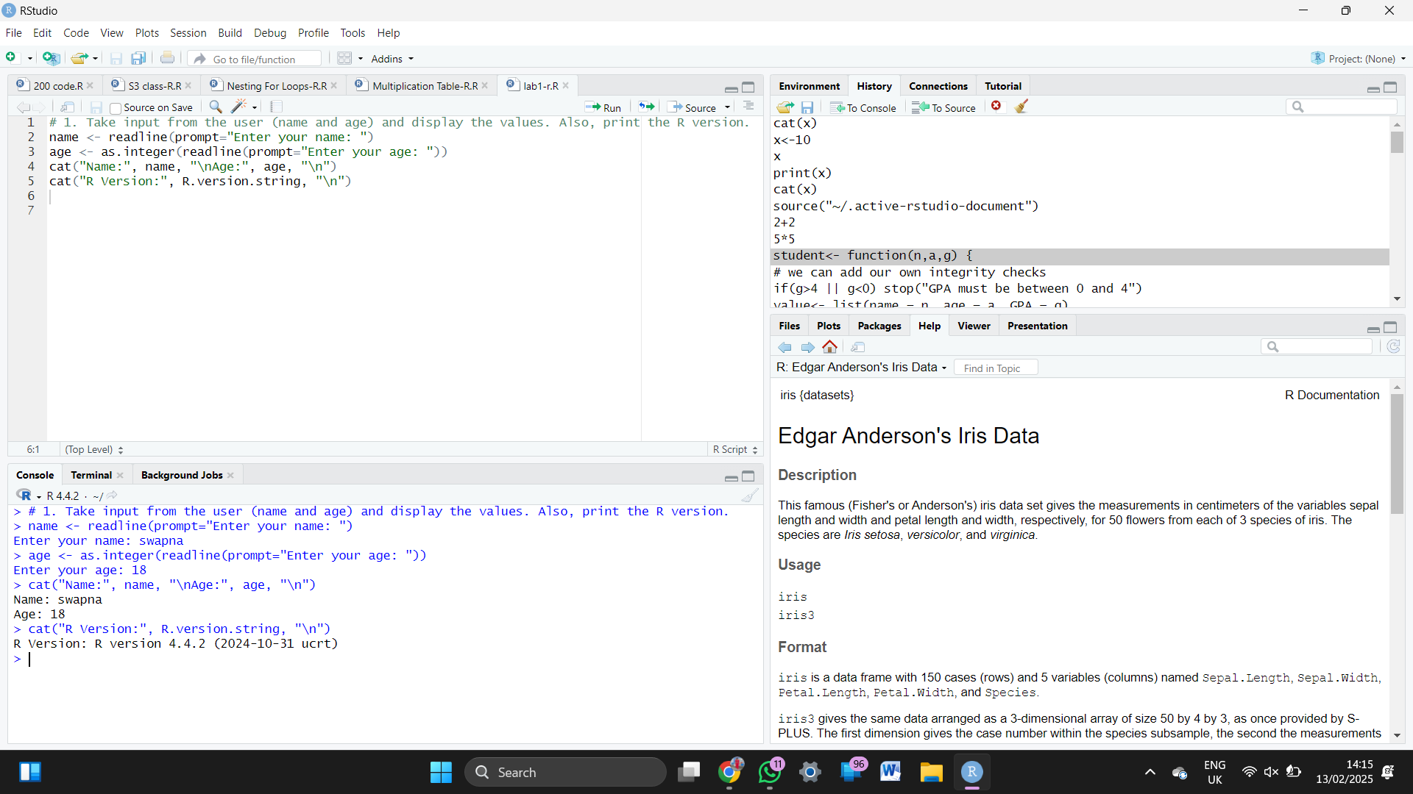

2.Write a R program to get the details of the objects in memory

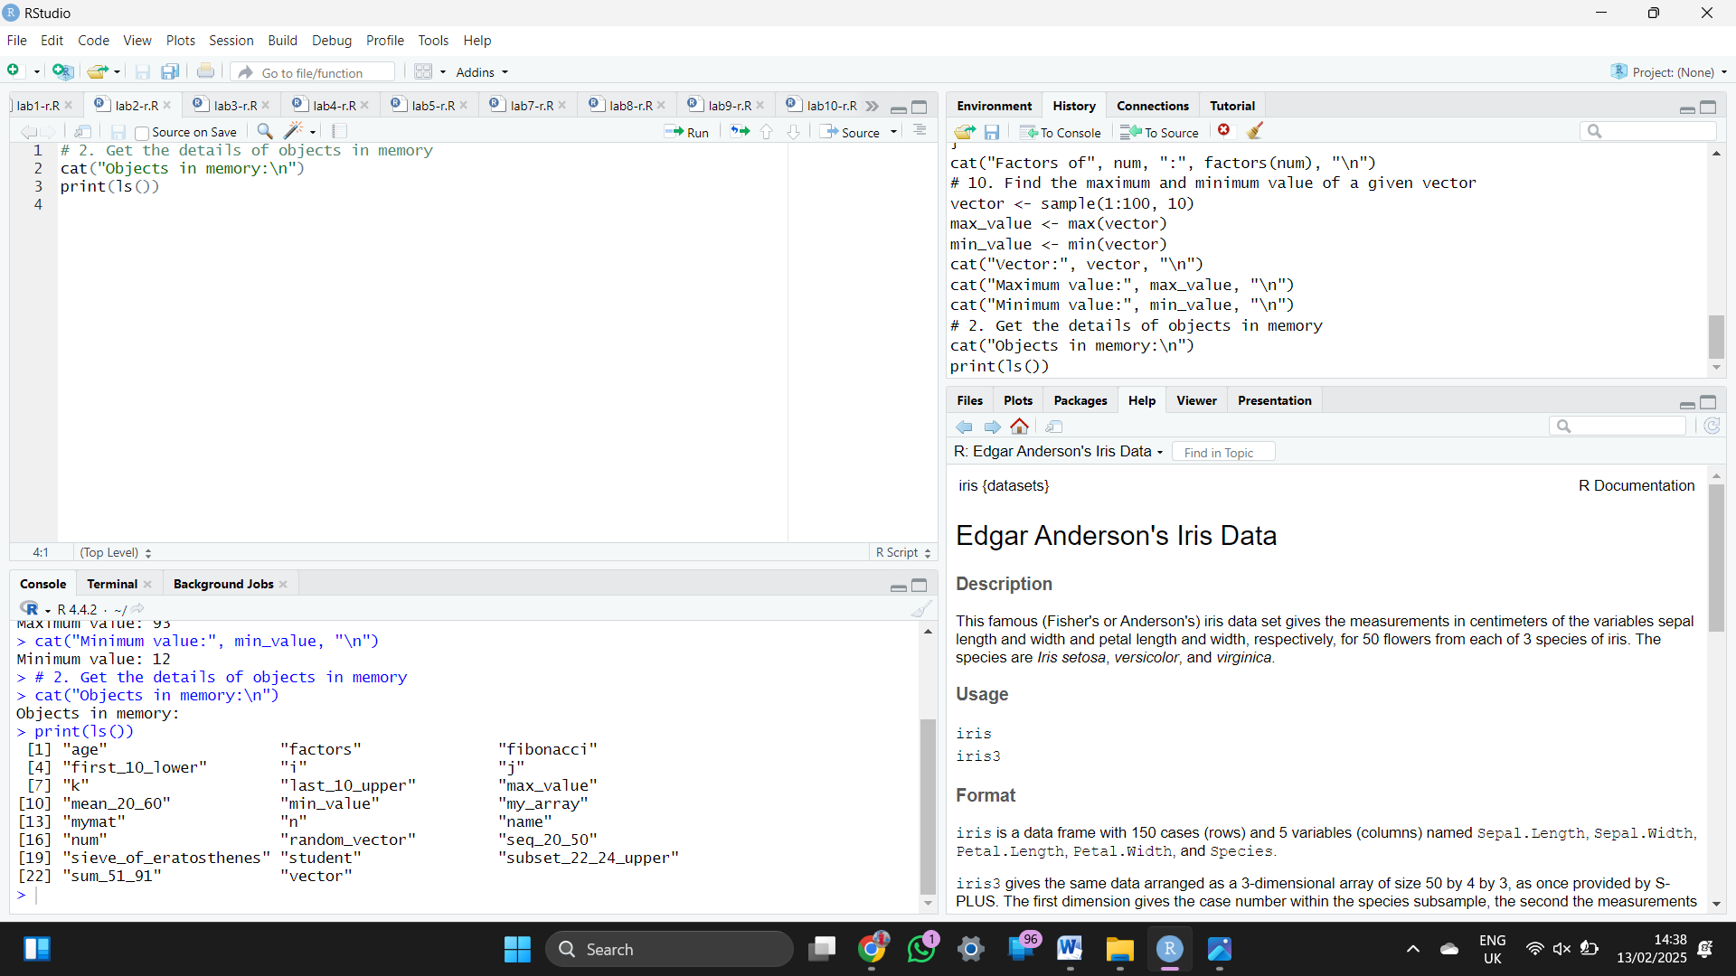

3.Write a R program to create a sequence of numbers from 20 to 50 and find the mean of numbers from 20 to 60 and sum of numbers from 51 to 91

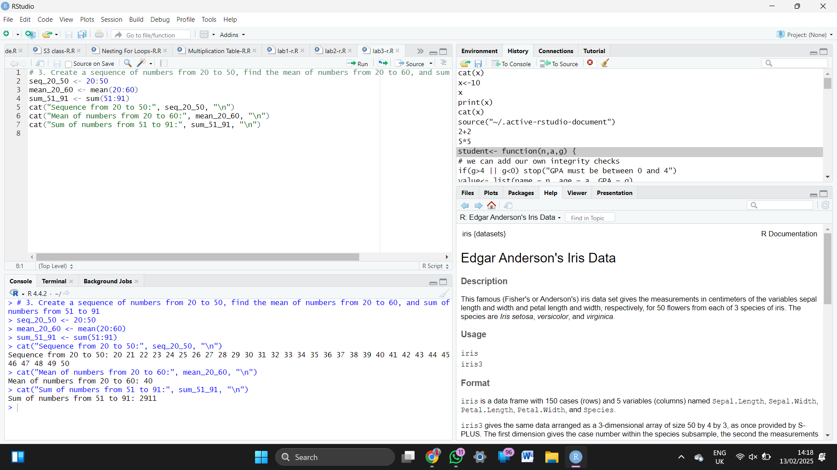  
  
  
4.Write a R program to create a vector which contains 10 random integer values between -50 and +50.

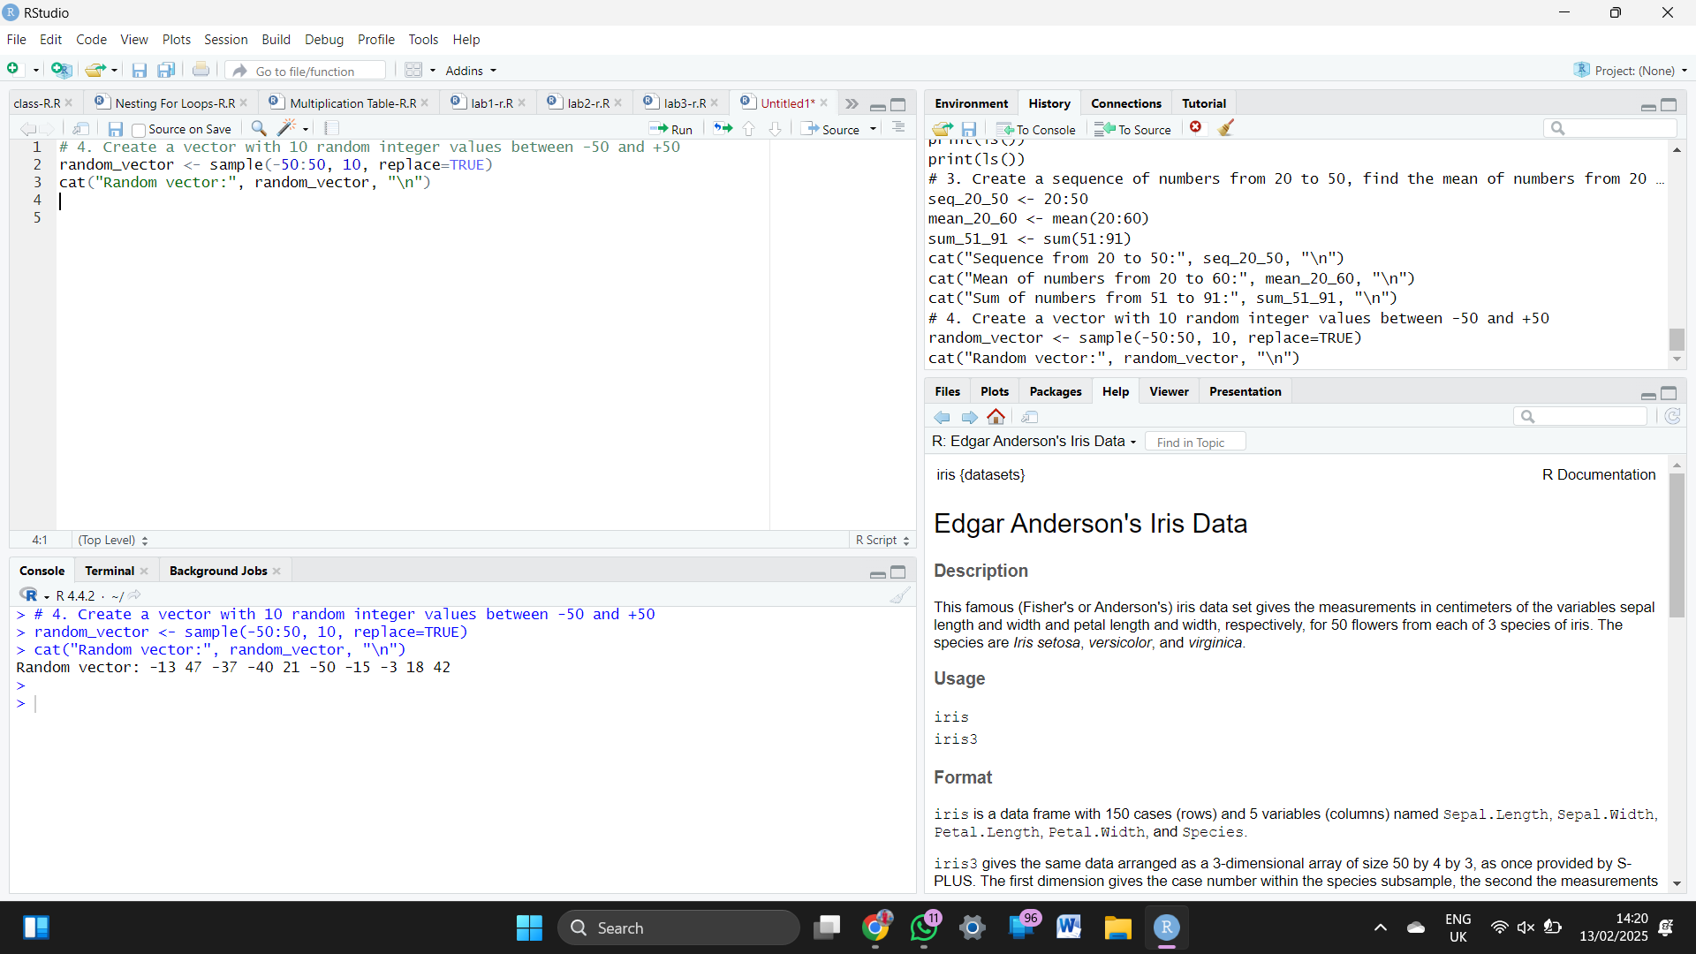  
  
  
5.Write a R program to get the first 10 Fibonacci numbers.

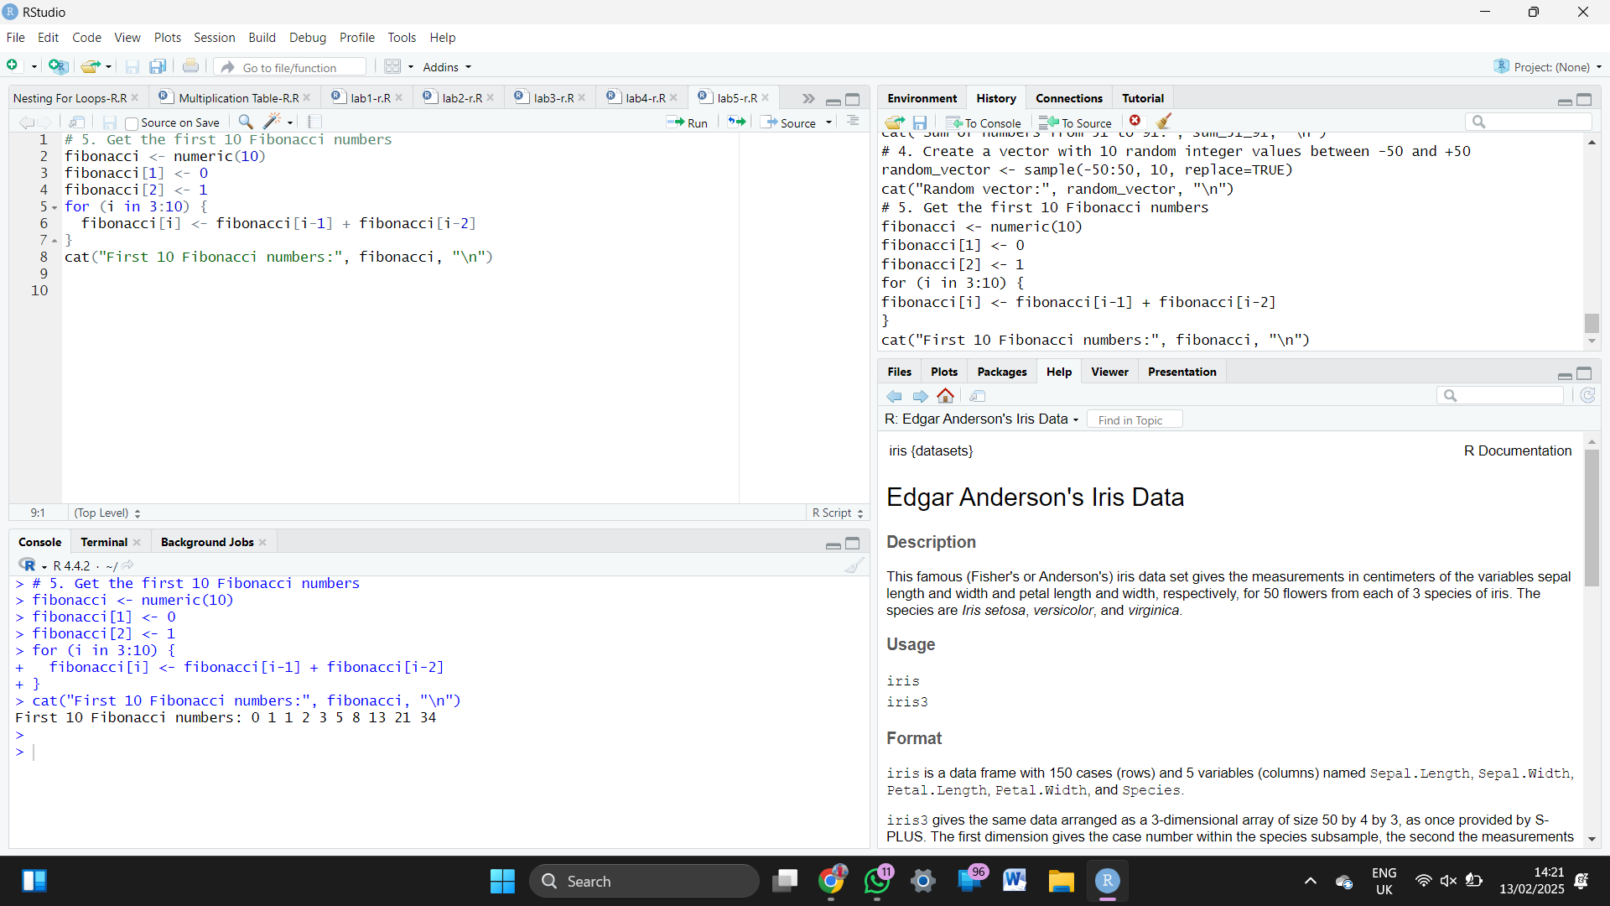  
  
  
6.Write a R program to get all prime numbers up to a given number (based on the sieve of Eratosthenes)

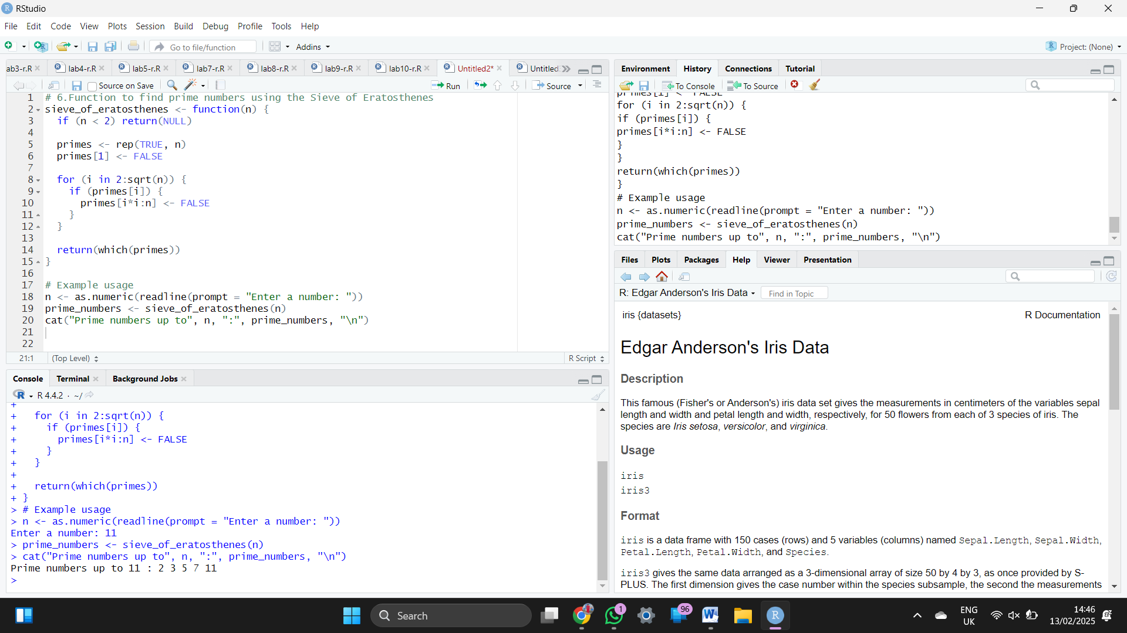

7. Write a R program to print the numbers from 1 to 100 and print "Fizz" for multiples of 3, print "Buzz"  
for multiples of 5, and print "FizzBuzz" for multiples of both.  
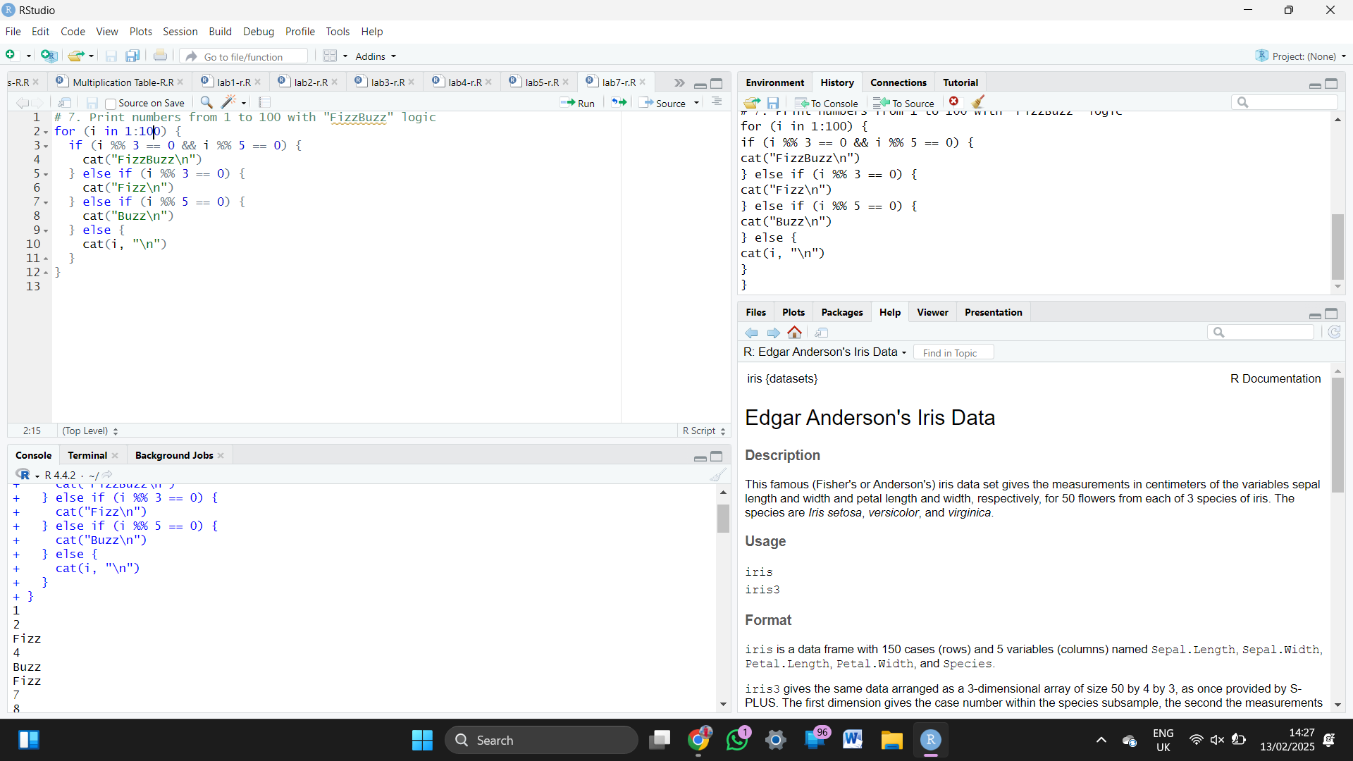  
  
8.Write a R program to extract first 10 English letters in lower case and last 10 letters in upper case and extract letters between 22nd to 24th letters in upper case.

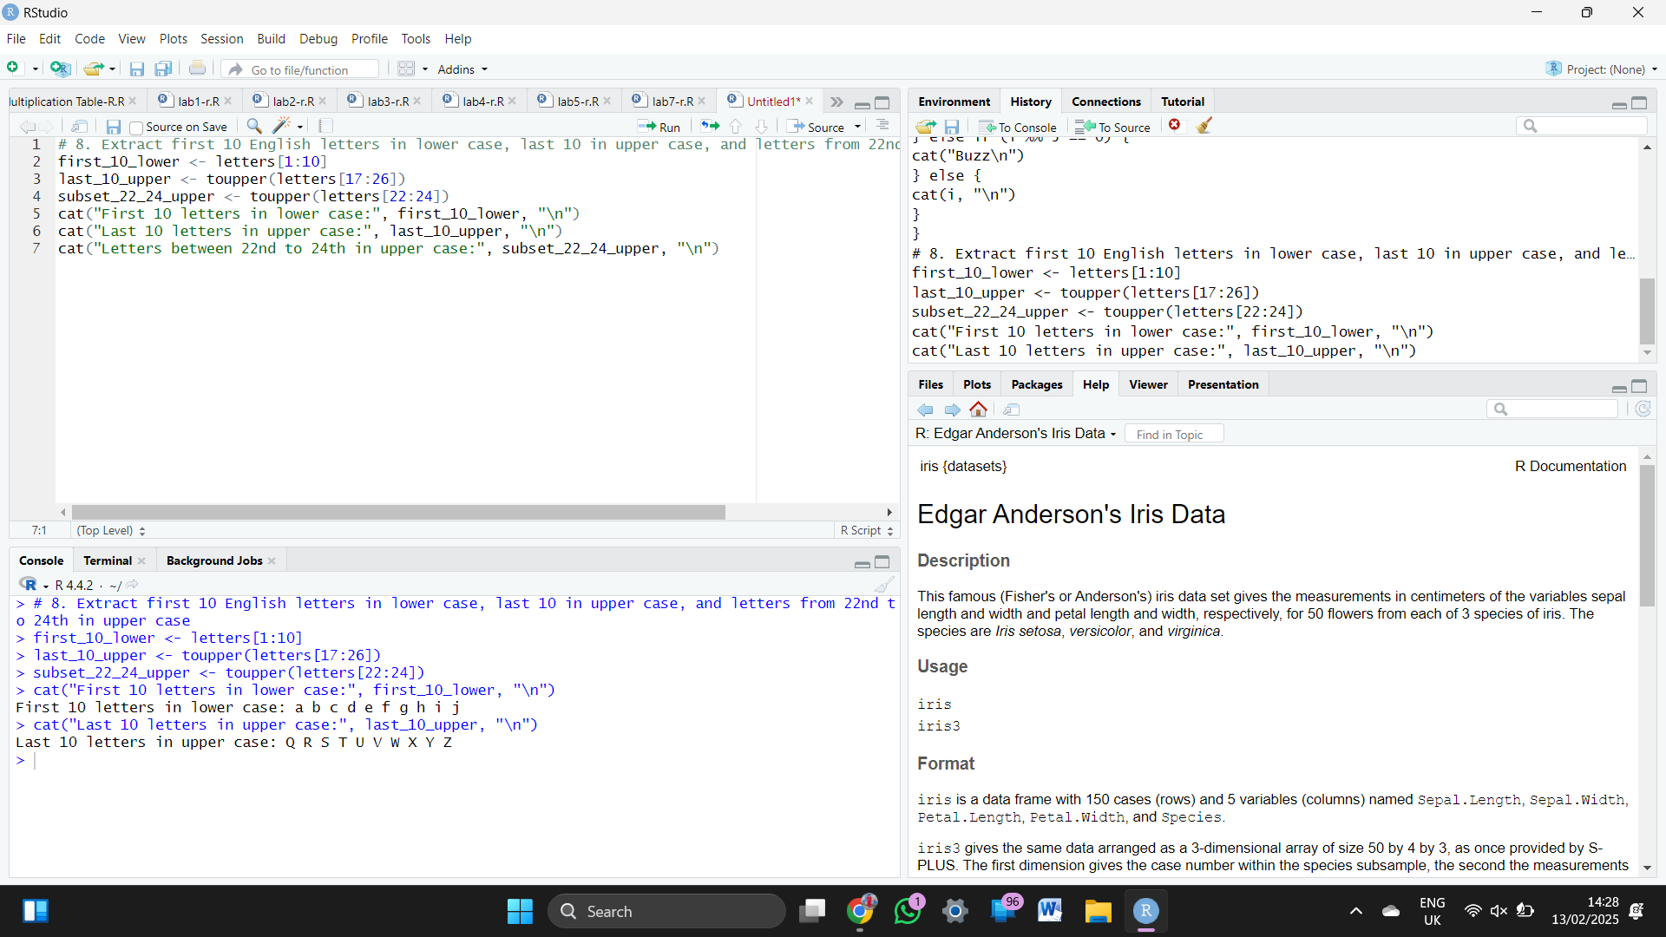  
  
  
9. Write a R program to find the factors of a given number

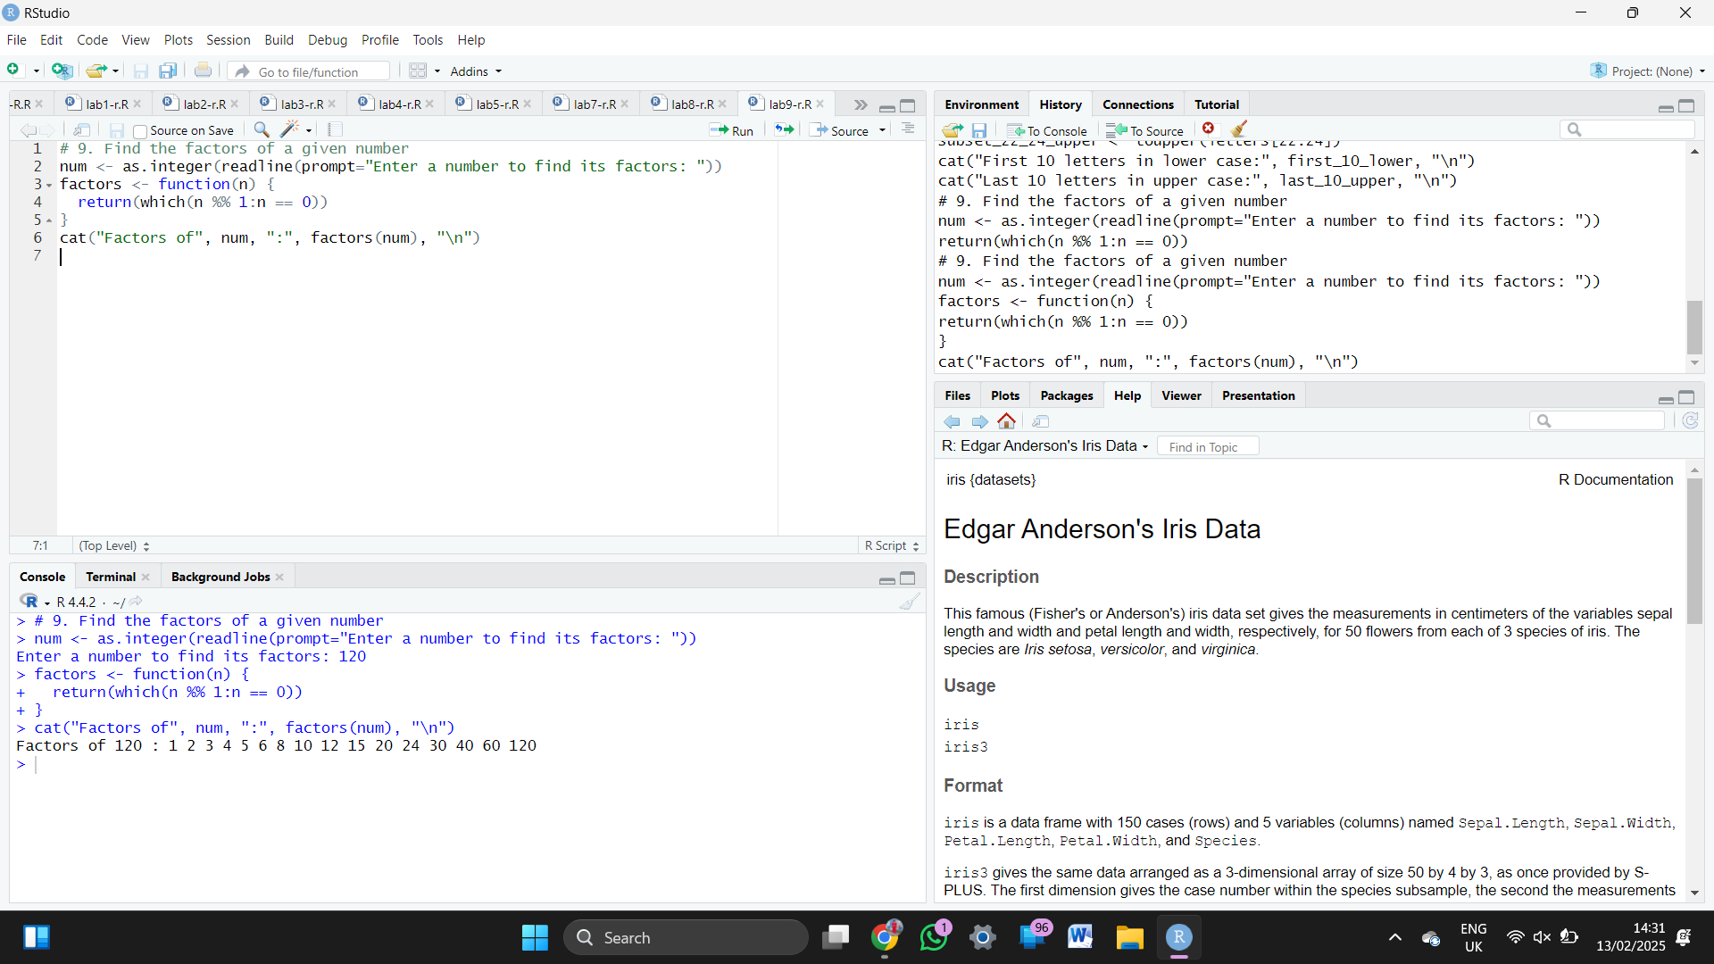  
  
10. Write a R program to find the maximum and the minimum value of a given vector

